

**CSE6224 SOFTWARE REQUIREMENTS ENGINEERING**

**TRIMESTER 2510**

**PROJECT PART 1**

# Table of Contents

**Table of Contents** **2**

**1. Elicitation Execution** **3**

1.1 Elicitation Method 1 - Brainstorming 3

1.2 Elicitation Method 2 - Questionnaire 8

1.3 Elicitation Method 3 - Interview 19

**2. Kano Model** **21**

# 

# 1. Elicitation Execution

## 1.1 Elicitation Method 1 - Brainstorming

The brainstorming technique is used to create a consensus on the various activities and functionalities that a system admin will conduct. Following are the description of the technique used:

**Brainstorming session #1**

**Title: Project Vision**

**Date: 30th April 2025, 10:00-12:00.**

**Participants:** Tham Yong Shian, Ahmad Farhan Zikri Bin Ahmad Fara, Mohamad Ammarul Azim Bin Mohamad Yusof.

‍**Goals / Issues:** Discuss about the project vision, scopes and goals.

‍**Results:**

* Project Vision: To achieve a system to streamline and convenience a student’s health and wellness
* Project Scope
  + Integration with the university healthcare system
    - Schedule appointments for medical services.
    - View and keep tabs of personal medical history.
    - Receive notifications for upcoming reservations.
  + Integration with the campus recreation facility management software
    - Book and retain time slots for recreational purposes.
    - View timetable for weekly exercises.
    - Avoid conflict between class schedule and workout time.
  + Personal Wellness Management
    - Set personal wellness goals and performances.
    - Progress tracking of previous and future activities.
    - Track your schedule outside of exercising. (e.g., sleeping, stress management, mealtime)
  + Tailored Health Resources
    - Receive personalised health advice and recommendations.
    - Access various educational materials for a healthy lifestyle.
    - Enjoy personalised content to watch or listen to, (e.g., meal preps, workout music, types of exercise)
* Project Goal
  + Centralize access to campus wellness services in a single platform.
  + Encourage students to take the initiative to achieve a better lifestyle.
  + Facilitate the process of booking and making an appointment.
  + Reduce the conflicts between study schedules and free time activities.
  + Cultivate a healthy habit that includes fitness, diet, and stress-free living.

Evidence: 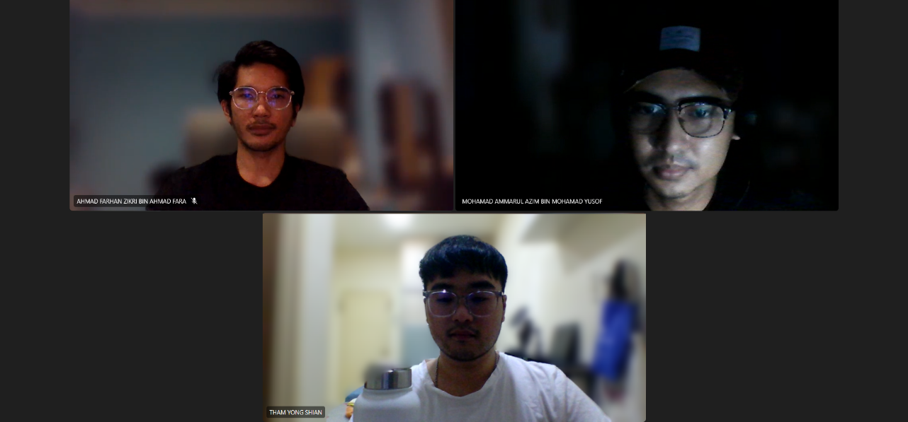

**Brainstorming session #2**

**Title: Stakeholders and Elaboration**

**Date: 1st May 2025, 16:00-18:00.**

**Participants:** Tham Yong Shian, Ahmad Farhan Zikri Bin Ahmad Fara, Mohamad Ammarul Azim Bin Mohamad Yusof.

‍**Goals / Issues:** Identify stakeholders, their interest and their impact in the system.

‍**Results:**

* Student
  + Interest:
    - The end user for the system.
    - As the primary user, they have an interest in ensuring that the system performs the required functionalities for the user to be able to perform their operations.
  + Impact:
    - The entire system is built around their convenience and involvement. The usability of the system and feature design are all shaped according to their interest and feedback.
* Medical staff
  + Interest:
    - The medical staff has an interest in managing the health of the students.
  + Impact:
    - The system should incorporate their workflow to avoid any unnecessary complication.
* Fitness coordinator
  + Interest:
    - The fitness coordinator has an interest in managing the physicality of the students.
  + Impact:
    - The system should incorporate their workflow to avoid any unnecessary complication.
* System admin
  + Interest:
    - The system admin has an interest in ensuring the system’s cost, schedule, quality, risks and issues are carefully monitored, managed and that newer implementations of functionality be approved.
  + Impact:
    - The system must comply with the admin's visions, missions, and terms and conditions to drive operational priorities.

Evidence: 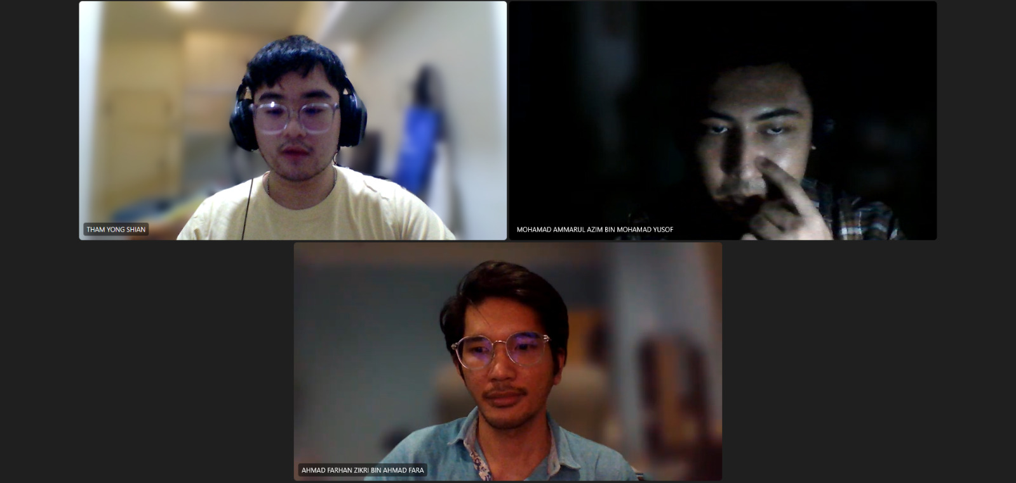

**Brainstorming session #3**

**Title: System Actors and Use Cases**

**Date: 8th May 2025, 14:00-16:00.**

**Participants:** Tham Yong Shian, Ahmad Farhan Zikri Bin Ahmad Fara, Mohamad Ammarul Azim Bin Mohamad Yusof.

‍**Goals / Issues:** List the various use cases and functional operations that stakeholder should operate with.

‍**Results:**

* Use Cases for Student
  + Login
  + Register
  + Schedule Appointment
  + Book Fitness Class
  + View Timetable
  + Set Personal Goals
* Use Cases for Medical Staff
  + Login
  + Provide personalised data
  + Post media
  + Manage appointment
  + Update medical record
  + Monitor student progress
* Use Cases for Fitness Coordinator
  + Login
  + Post media
  + Manage booking
  + Assign fitness classes
  + Add fitness classes
* Use Cases for Admin
  + Login
  + Manage User Account
  + Monitor System Performance
  + Manage Content Updates
* Use Cases for Medical Software System
  + Send event reminder
  + Search reservation
  + Save date
  + Upload media
* Use Cases for Fitness Software System
  + Event reminder
  + Search free slot
  + Save date

Evidence: 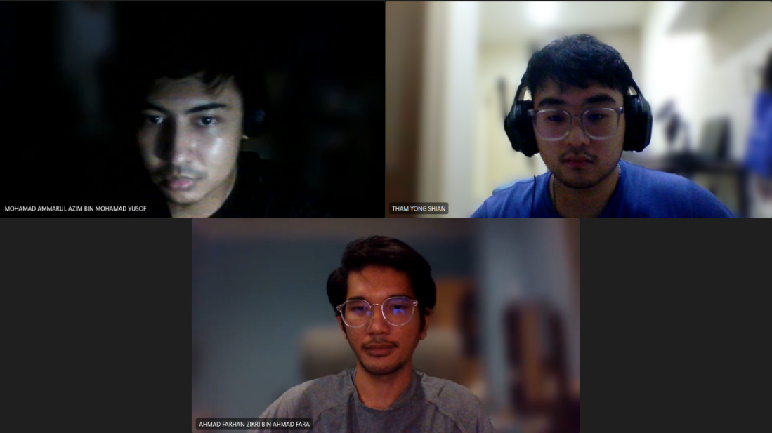

**Brainstorming session #4**

**Title: System Admin Elicitation**

**Date: 15th May 2025, 13:00-14:00.**

**Participants:** Tham Yong Shian, Ahmad Farhan Zikri Bin Ahmad Fara, Mohamad Ammarul Azim Bin Mohamad Yusof.

‍**Goals / Issues:** Elicit requirements for system admin stakeholder.

‍**Results:**

* Admin is required to login using a special identifier. Categorised as a dissatisfier.
* Admin is provided with a document on how to use the system. Categorised as a satisfier.
* Admin is provided with an admin panel. Categorised as a dissatisfier.

Evidence: 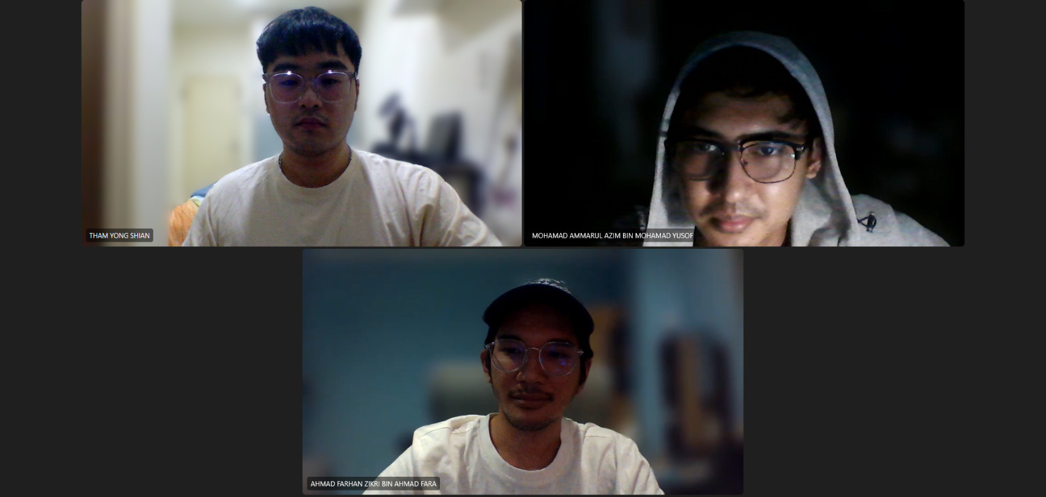

## 

## 1.2 Elicitation Method 2 - Questionnaire

The questionnaire technique will be used to classify and gather information from a large number of stakeholders, since it is impossible to group together a huge number of students and be interviewed one at a time. Additionally, using the questionnaire technique provides a controlled environment, expediting the process of getting information .

**Requirement 1: Login with ID / credentials**

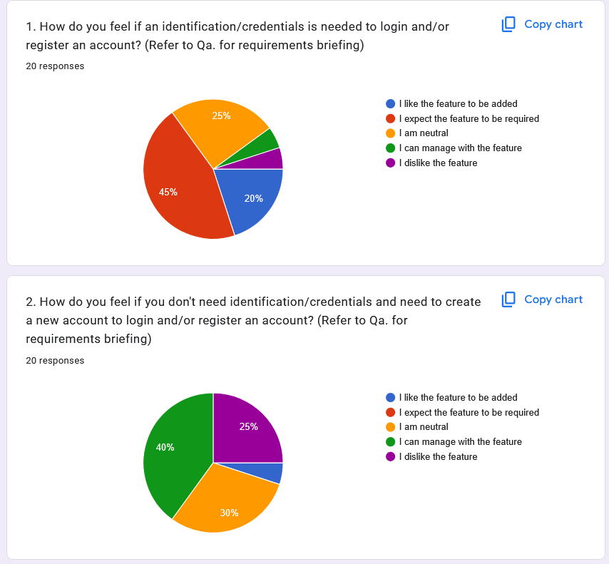

Figure 1.1

**Requirement 2: Schedule appointment with medical staff**

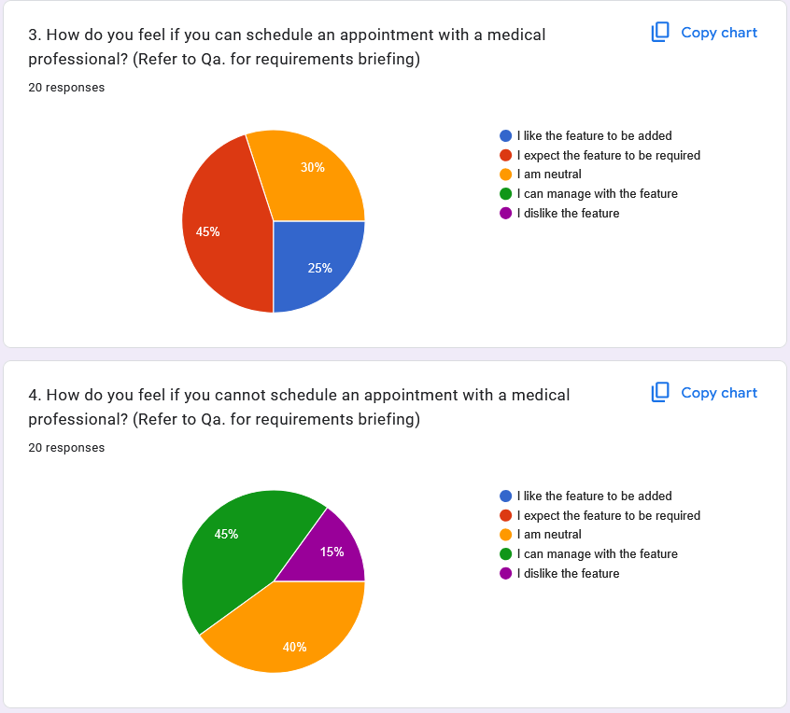

Figure 1.2

**Requirement 3: Book fitness class from fitness coordinator**

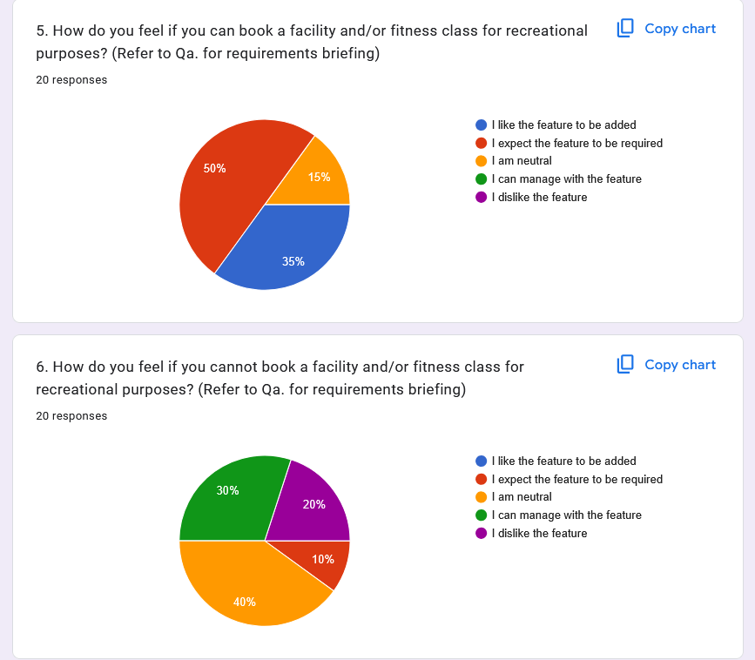

Figure 1.3

**Requirement 4: View upcoming activities**

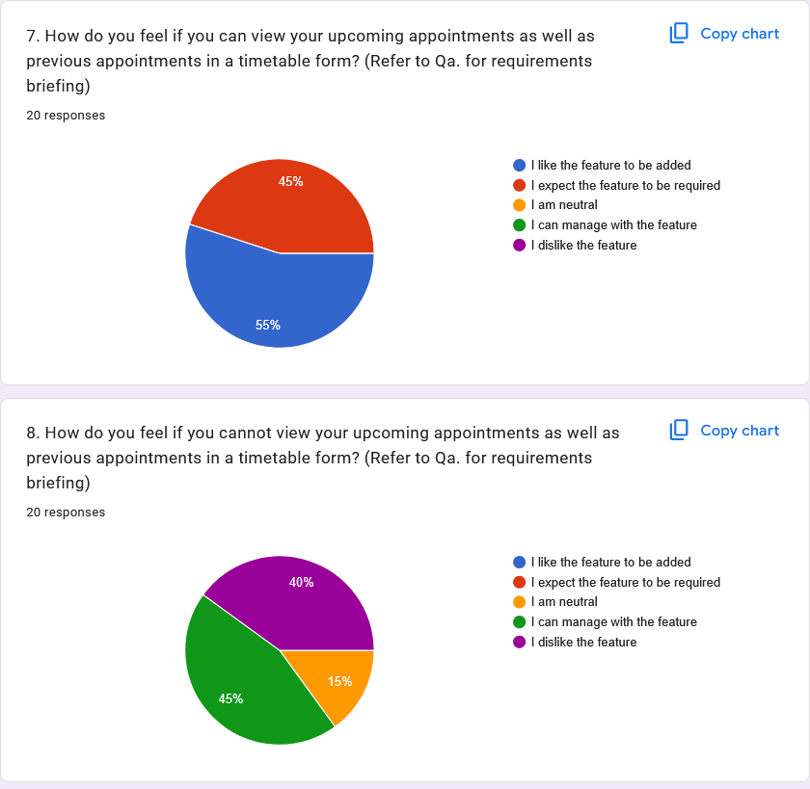

Figure 1.4

**Requirement 5: Set and track personal goal**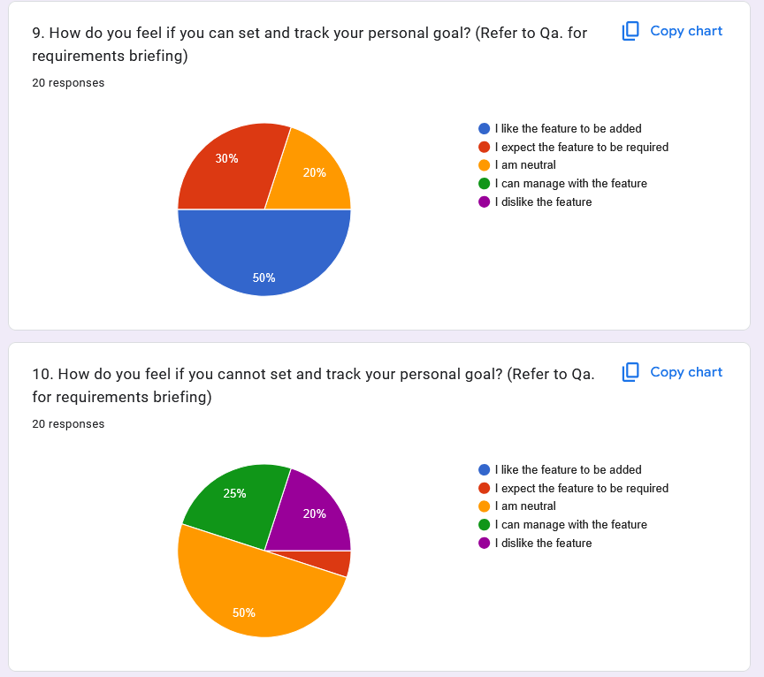

Figure 1.5

**Requirement 6: Receive personalized health content**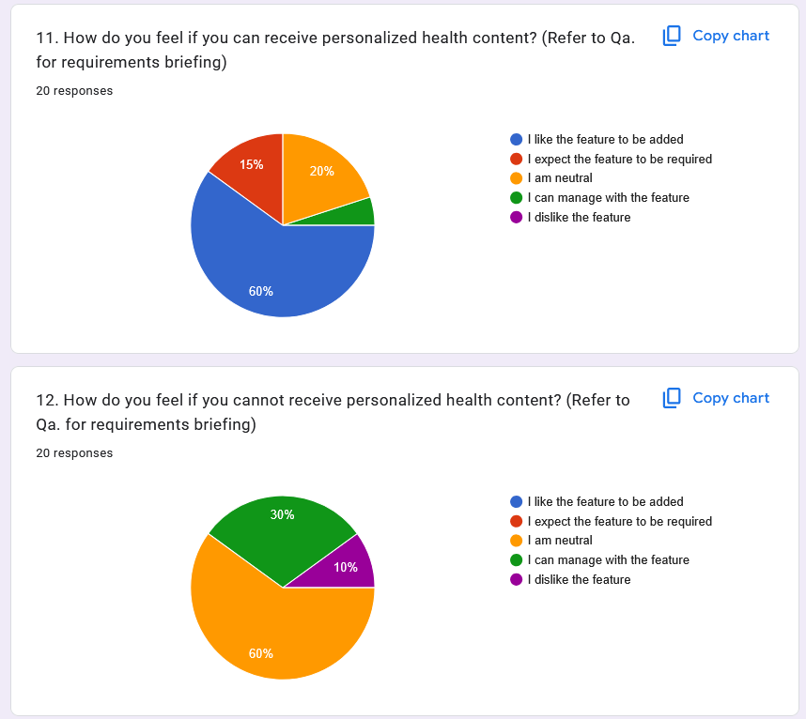

Figure 1.6

**Requirement 7: Watch personalized media content**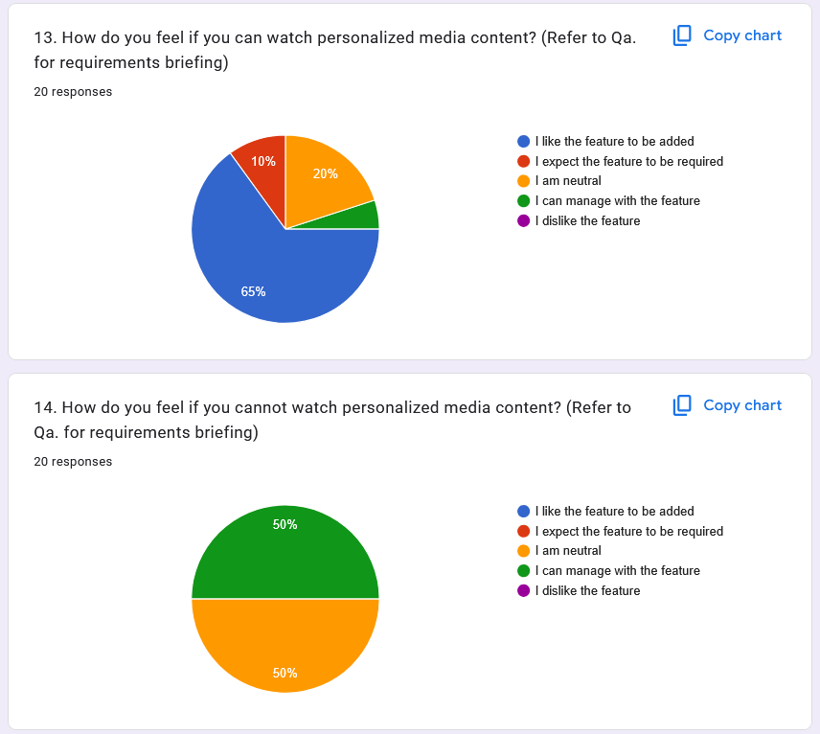

Figure 1.7

**Requirement 8: Chat with online support**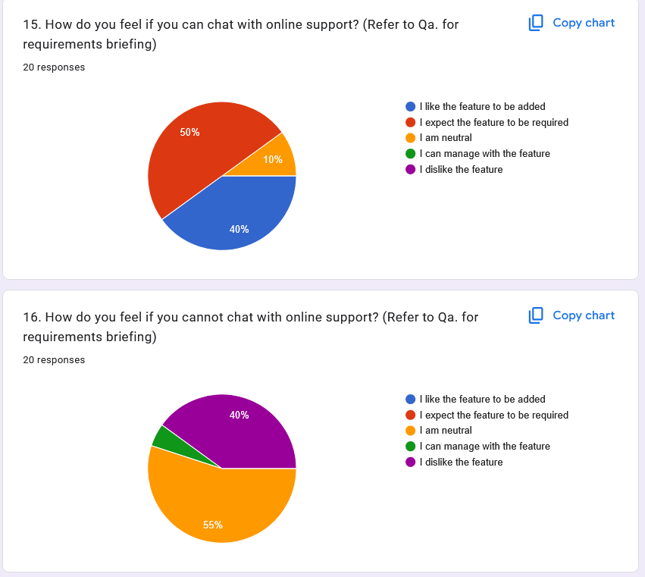

Figure 1.8

**Requirement 9: Receive notification and reminder**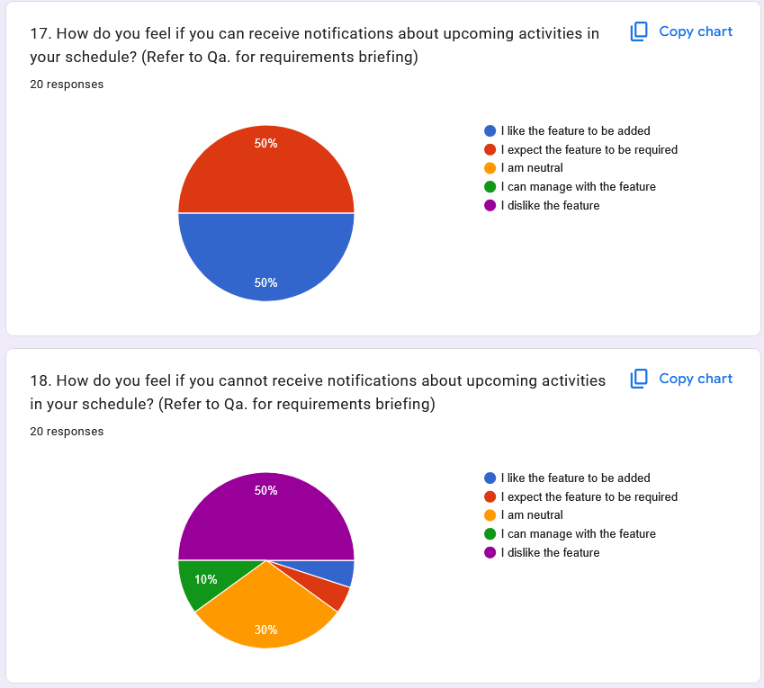

Figure 1.9

**Requirement 10: Search for free time slot**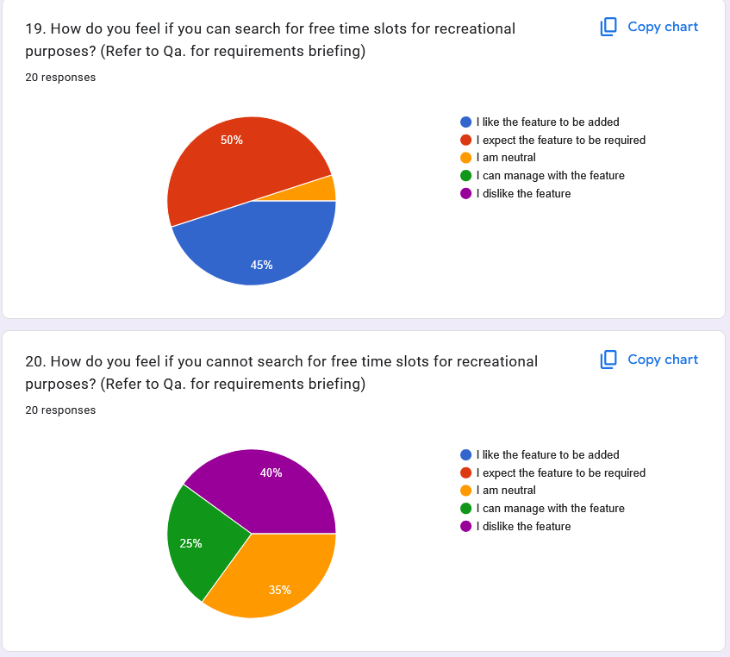

Figure 1.10

**Requirement 11: Submit user feedback**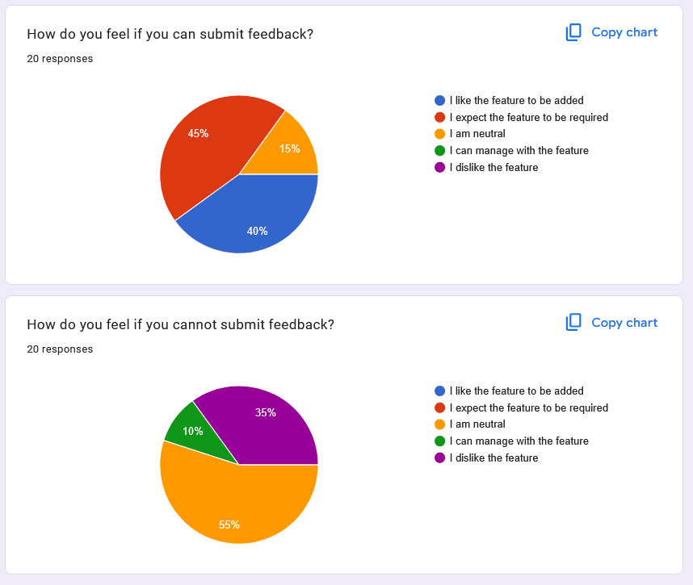

Figure 1.11

Evidence: [Campus Wellness Portal (Responses)](https://docs.google.com/spreadsheets/d/1v9dElLKEZxa3B5py-L0MkOzMA0rbSdgrUK3_BGXbIR4/edit?usp=sharing) (https://docs.google.com/spreadsheets/d/1v9dElLKEZxa3B5py-L0MkOzMA0rbSdgrUK3_BGXbIR4/edit?usp=sharing)

## 1.3 Elicitation Method 3 - Interview

The interview technique will allow a better understanding of functionalities to streamline operations and avoid any complications. Following are the description of various interviews conducted:

**Interview Session #1**

| Identifier | REQ_INT001 |
| --- | --- |
| Date | 23.05.2025 |
| Goal | Elicitation of requirements for the medical staff stakeholder in Campus Wellness Portal with Medical System and Fitness Center Integration. |
| Interviewer | Tham Yong Shian |
| Interviewee(s) | Tan Kok Tong (Intern Pharmacist, ALPRO Pharmacy Semenyih Taman Pelangi) |
| Minutes | * Is fine with using ID/credentials to login and access the portal if the ID isn’t connected to personal information and there’s 2FA. * Can manage with the feature of managing appointments, suggested to add a reasoning when denying an appointment. * Would love to see upcoming event notifications and reminders. * Love the idea of monitoring student’s health progress if given a way to encrypt said data. * Dislike the idea of giving health advice since it’s always general advice that is given commonly. * Love the idea of assessing and monitoring student health records if given a way to encrypt said data. * Love the idea of online chat support but it is discouraged since medical staff are busy. * Love the idea but it is discouraged since medical staff are busy and there’s a difference in perspective amongst the classes. |

Table 1.1

Evidence:

Photo:  


Figure 1.12

Voice Recording: https://youtu.be/TjZ5NWhmnO8

**Interview Session #2**

| Identifier | REQ_INT002 |
| --- | --- |
| Date | 23.05.2025 |
| Goal | Elicitation of requirements for the medical staff stakeholder in Campus Wellness Portal with Medical System and Fitness Center Integration. |
| Interviewer | Tham Yong Shian |
| Interviewee(s) | Mieko (Intern Nurse, Ivoris Medical Clinic and Ivoris Dental Clinic) |
| Minutes | * Deems using an ID for login is necessary. * Believed it is necessary to manage student’s appointments, suggested adding a reason for declining appointments. * The function to see upcoming event notifications and reminders is a requirement. * Is neutral on the ability to monitor student’s progress. * Assume it is necessary to give advice in order to help students. * The function of assessing and monitoring student health records is necessary. * Doesn’t want the function of online chat support since they are usually busy with their schedules. * Doesn’t want the function of posting media since it is hard to interest students by only posting content. |

Table 1.2

Evidence:

Photo:

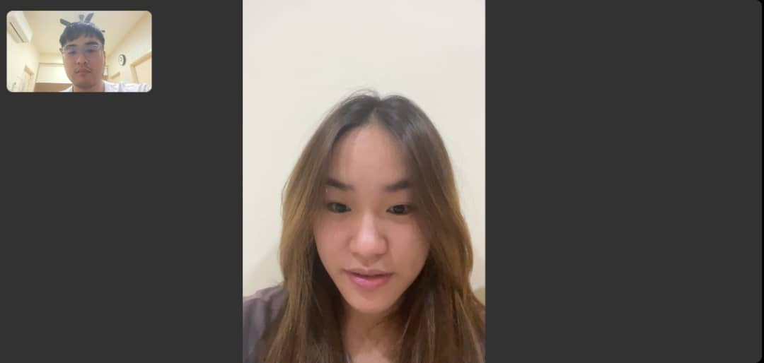

Figure 1.13

Voice Recording: https://youtu.be/n5tdmOOaD_0

**Interview Session #3**

| Identifier | REQ_INT003 |
| --- | --- |
| Date | 23.05.2025 |
| Goal | Elicitation of requirements for the fitness coordinator stakeholder in Campus Wellness Portal with Medical System and Fitness Center Integration. |
| Interviewer | Tham Yong Shian |
| Interviewee(s) | Dyson Hong (Volleyball Coach, Grace Volleyball Academy) |
| Minutes | * Using ID to login is absolute. * Think it is a good addition to add fitness classes but don't think it’s a requirement. * The ability to assign activities is sufficient. * It is reasonable to deny booking if classes are full. * Upload and post media is a good addition as it promotes students to do sport. |

Table 1.3

Evidence:

Photo:



Figure 1.14

Voice Recording: https://youtu.be/4nLYGFwi5kM

**Interview Session #4**

| Identifier | REQ_INT004 |
| --- | --- |
| Date | 23.05.2025 |
| Goal | Elicitation of requirements for the fitness coordinator stakeholder in Campus Wellness Portal with Medical System and Fitness Center Integration. |
| Interviewer | Tham Yong Shian |
| Interviewee(s) | Kenny Liu Boh Yong (Badminton Trainer, Sungai Chua Food & Sports Centre) |
| Minutes | * Login with ID is essential for easy identification for the university. * Think it is necessary to add fitness classes for student’s health and study balance. * Don't think it’s required to assign activities to provide students with freedom. * Approving / denying booking isn’t needed to allow students to participate in sport. * Love the idea of posting media for students as they are all on social media nowadays. |

Table 1.4

Evidence:

Photo:



Figure 1.15

Voice Recording: https://youtu.be/rSqnrCI4K8A

# 2. Kano Model

The Kano model is a theory for product development and [customer satisfaction](https://en.wikipedia.org/wiki/Customer_satisfaction) developed in the 1980s by [Noriaki Kano](https://en.wikipedia.org/wiki/Noriaki_Kano). This model provides a framework for understanding how different features of a product or service impact customer satisfaction, allowing organizations to prioritize development efforts effectively. According to the Kano Model, customer preferences are classified into five distinct categories, each representing different levels of influence on satisfaction.

Requirements can be classified into 6 classes, Attractive, Performance, Must-have, Reverse, Indifferent, and Questionable, by cross referencing various elicitation results to the Kano evaluation chart shown below.

Kano evaluation chart:

| Functional | Dysfunctional | | | | | |
| --- | --- | --- | --- | --- | --- | --- |
|  | I like it | I expect it | I am neutral | I tolerate it | I dislike it |
| I like it | Q | A | A | A | P |
| I expect it | R | Q | I | I | M |
| I am neutral | R | I | I | I | M |
| I tolerate it | R | I | I | Q | M |
| I dislike it | R | R | R | R | Q |

Table 1.5

## 2.1 Results

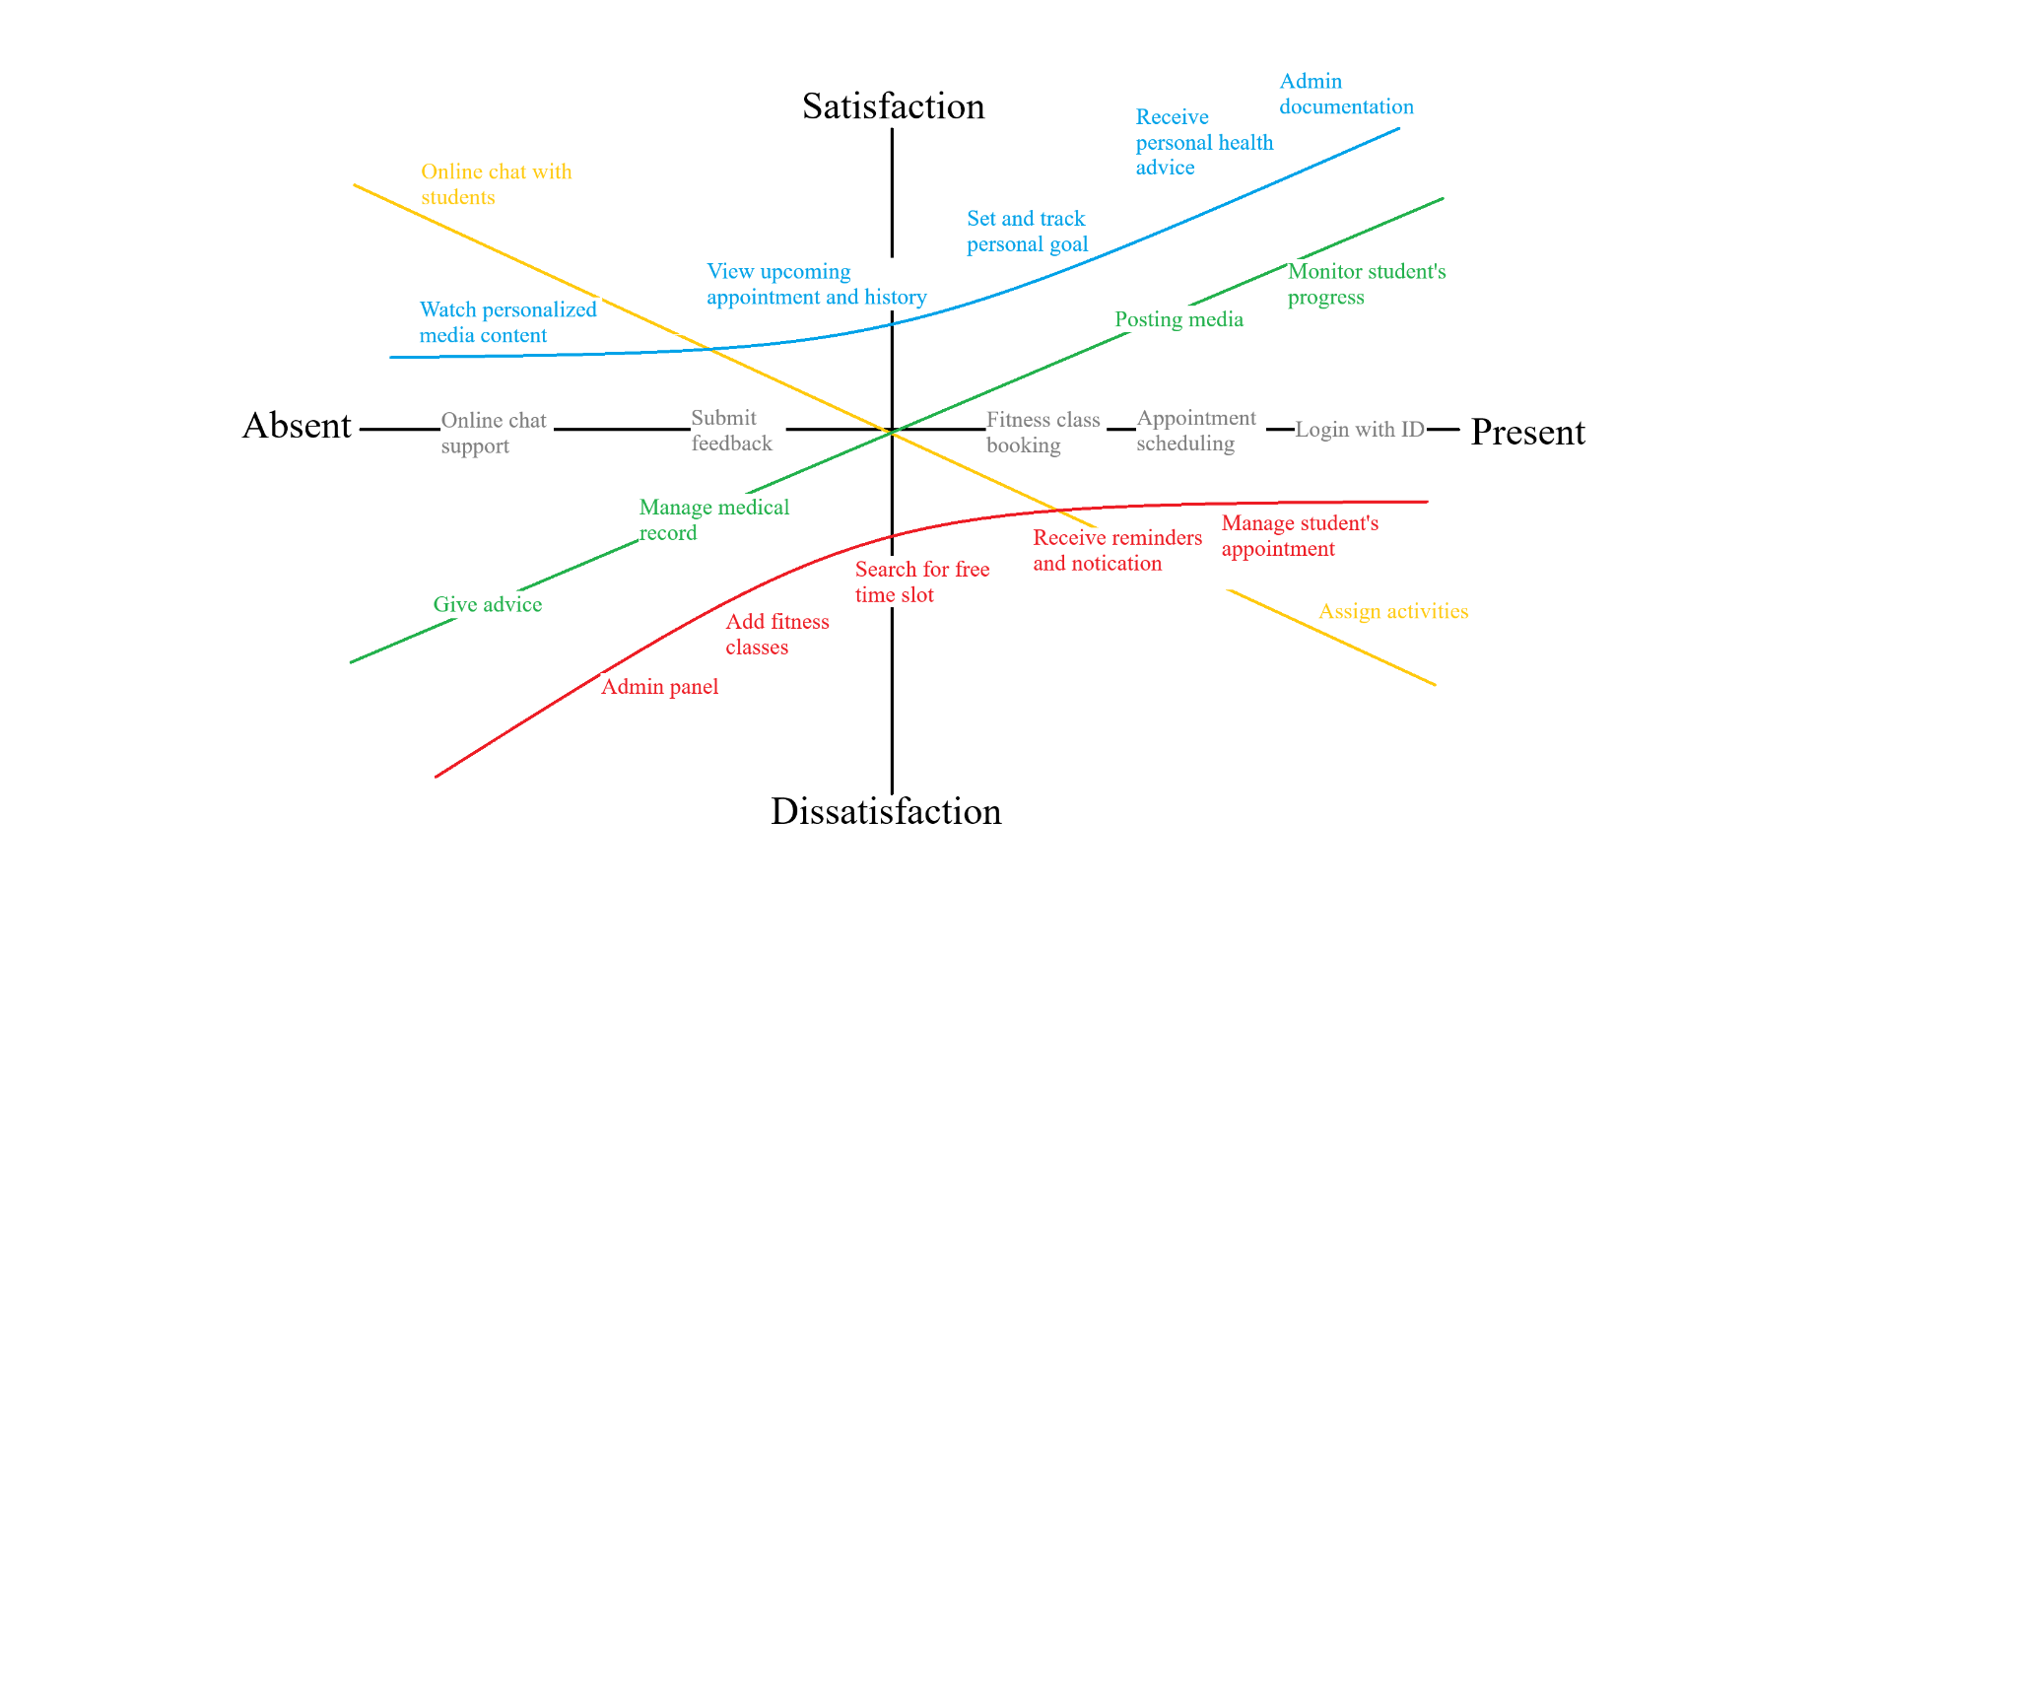

Figure 2.1